**Project Deliverable 2 – Documentation and Coding**

**Faculty Name:** Information Technology

**Module Code:** ITECA3-B12

**Module Name:** Web Development and e-Commerce

**Content Writer:** Kariboba Mpwampu

**Copy Editor:** Mr Kyle Keens

**Submission Date:** Block 2 Week 4

|  |  |
| --- | --- |
| **Student Name** | Saishen Pillay |
| **Student Number** | HCZVHYQY8 |
| **Project Title** | Deliverable 2 – Documentation and Coding |
| **Submission Date** | 12/06/2023 |

**Table of Contents**

2.1 Introduction 3

2.2 Prototyping 3

2.3 Designing 17

2.4 Coding 23

2.5 Conclusion 30

2.6 Sign-off 32

# Introduction

In this delivery, I will create two website prototypes to present to Stakeholders/Mangers/Users. Stakeholders/Mangers/Users should choose the model they want me to continue using. Then I need to sketch and go through the planning phase of the website. Once it is complete, I will start coding the website using HTML, CSS, JavaScript ,Php Admin and JSON Files. The site needs to be an e-commerce Candy store that will showcase all the products the physical store "Sugar Rush" has for sale.

Users should be able to shop by: Product, add their favorite product to cart, view their cart (and remove/ add to cart), and then purchase everything in their cart.

# Prototyping

1. **Prototype 1**

**Home Page**

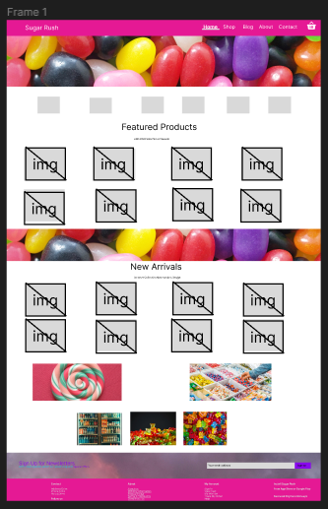

This is made up of a Navbar with the following headings (Home, Shop, Blog, About, Contact and a shopping cart. The Home Page displays 8 images of the Featured Products, it is then followed by a second banner, The New Arrival Section displays 8 images of the New Products. The user is then given 5 additional images to interact with which promotes the website strengths. The end of the page is made up of an Email section and a footer, the email is for encouraging the user to sign up for news regarding Sugar Rush. The footer is made up of Contact column (The address, Phone) About column( Links: About us, Delivery information, Privacy Policy, Terms& Conditions, Conditions Us), My Account ( Sign in, View Cart, My Wishlist,, Track My Order, Help), and a install section to advise the user to install an app.

Shop Page

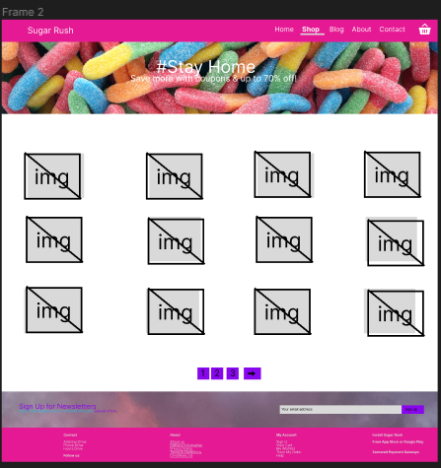

This is made up of a Navbar with the following headings (Home, Shop, Blog, About, Contact and a shopping cart. The page also has a unique banner. The Shop Page displays 12 images of the Products, it is then followed by 3 buttons that will lead the user to the proceeding pages. The end of the page is made up of an Email section and a footer, the email is for encouraging the user to sign up for news regarding Sugar Rush. The footer is made up of Contact column (The address, Phone) About column (Links: About us, Delivery information, Privacy Policy, Terms& Conditions, Conditions Us), My Account ( Sign in, View Cart, My Wishlist,, Track My Order, Help), and a install section to advise the user to install an app

Blog Page

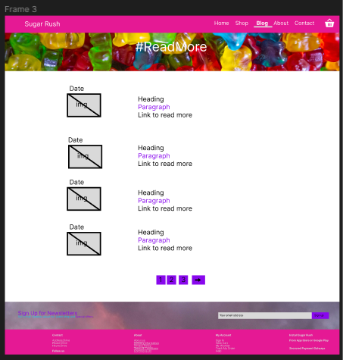

This is made up of a Navbar with the following headings (Home, Shop, Blog, About, Contact and a shopping cart. The page contains a unique banner. The Blog Page displays 4 images related to the image, it is then followed by a heading, paragraph, and a link to read more.

**About Page**

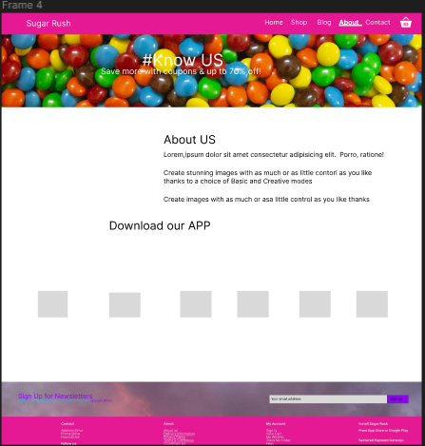

The page contains a navbar, header and text about the business, it includes an app hyperlink for the user, The page contains six Blocks near the bottom of the page, in the block will contain 6 attributes that the business has, such as 24/7 support, delivery etc, this is then proceeded by the newsletter and footer.

**Contact Page**

This is made up of a Navbar with the following headings (Home, Shop, Blog, About, Contact and a shopping cart. The page contains a unique banner. The Contact Page displays some information about the address, alongside a functional google. The bottom contains a form with the user’s name, email, subject, and a message and a submit button. Alongside the form display 3 images of the executives and managers.

Shopping Cart

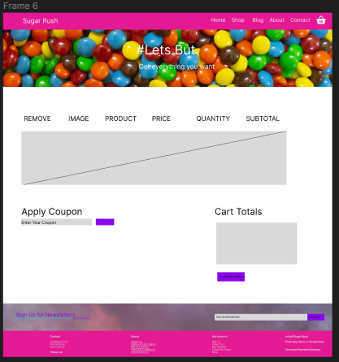

This is made up of a Navbar with the following headings (Home, Shop, Blog, About, Contact and a shopping cart. The page contains a unique banner. The shopping Page displays some information about the cart. (The table contains a remove row, displays an image, The products Name, Products Price, Quantity, Subtotal). Cart Totals is displayed in another table below. There is also an Apply Coupon that requires the user input and will also display in the Cart Total.

**Product Display page**

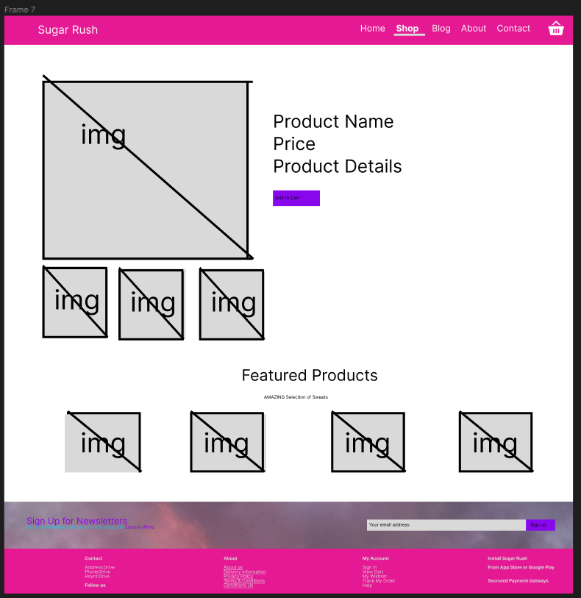

When the user clicks on the product, it takes them to this following page. The main image appears and three images related to the main image appear. Alongside the product is the Product Name, Price and Product Details. Under this section is a featured products section with four images.

1. **Prototype 2.**

**Both Prototypes have similar features, difference being the color scheme .**

**Home Page**

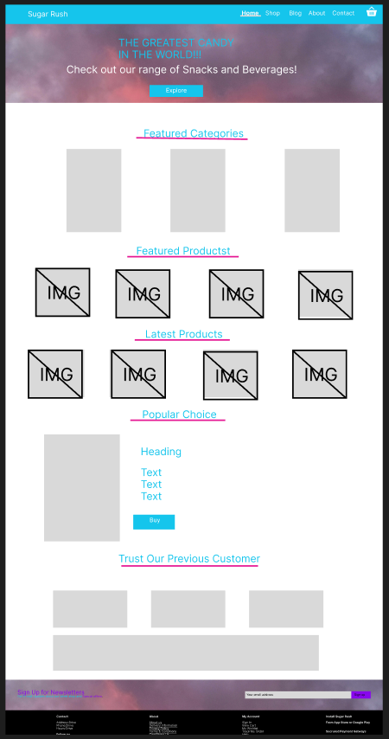

On the Home page there are three popular categories the user can choose from; the page then follows the same design elements for Featured and latest as Prototype 1. The popular choice displays a image of the right hand side and text on the left (containing the heading and description of the product). The page ends with Customers Reviews of the overall website split into 4 boxes, 3 next to each other and 1 right at the bottom.

**Shop Page**

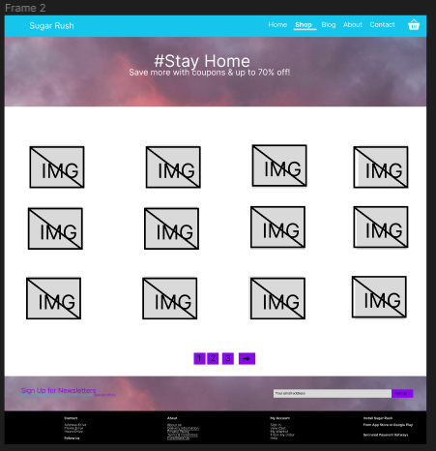

Blog Page

The Blog contains 4 images all containing a heading, paragraph and link. This is similar to Prototype 1 but carries a difference in terms of the layout, 2 are on the right and 2 are on the left

About Page

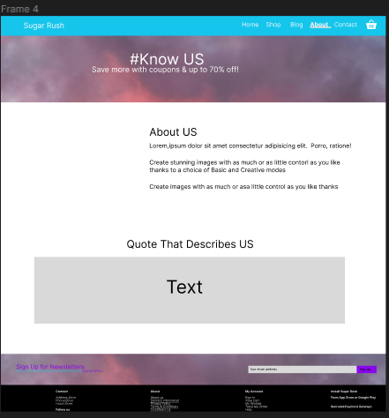

The About Page contains A similar layout to Prototype1, the only difference between the two is that Prototype2 have removed the 6 blocks and has replaced it with a section for a quote that represents the company.

Contact Page

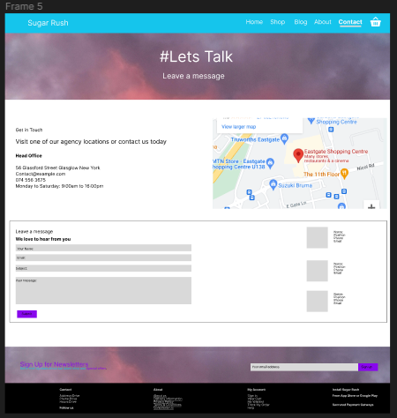

Cart Page

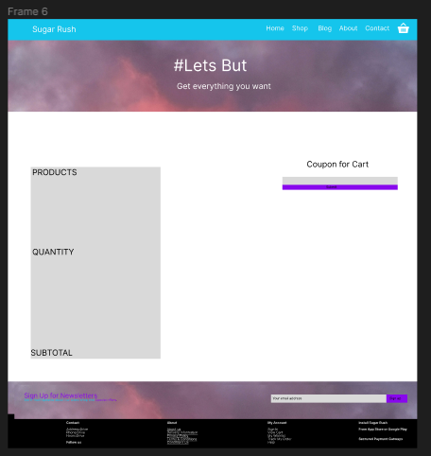

The cart page contains a table with the following headings, Products, Quantity and Subtotal. The table is displayed vertically alongside a coupon input.

The Login Page will remain the same for both Prototypes.

Based on the client’s needs, the most viable option would have to be **Prototype 1**, as it has simple look but has the correct functionality. It accomplishes the Goal the Business is trying to get across.

# Designing

1. **Class Responsibility Collaborator (CRC) cards**

1. **Enhanced Entity Relationship Diagram (EERD)**

1. **Context Diagram**

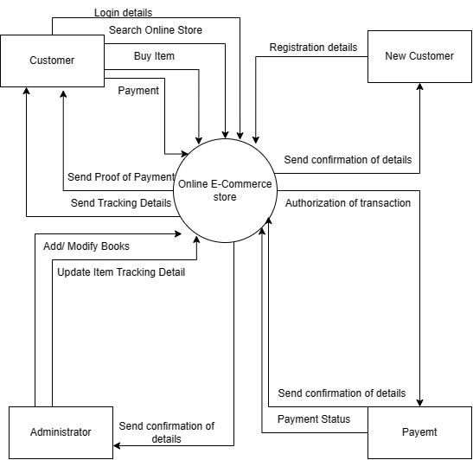

1. **Data Flow Diagram (DFD)**

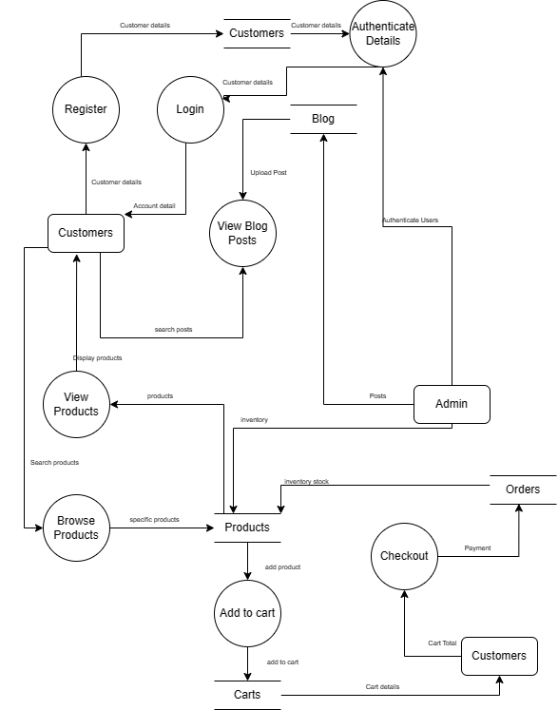

1. **Use Case DiagramA picture containing diagram, text, sketch, drawing

   Description automatically generated**
2. **Database Design**

# Coding

Provide the screenshots and code samples of the final website. You do not have to print every code on your website. Use the following as guideline and explain what each sample code provided is used for on the website:

1. **Screenshots**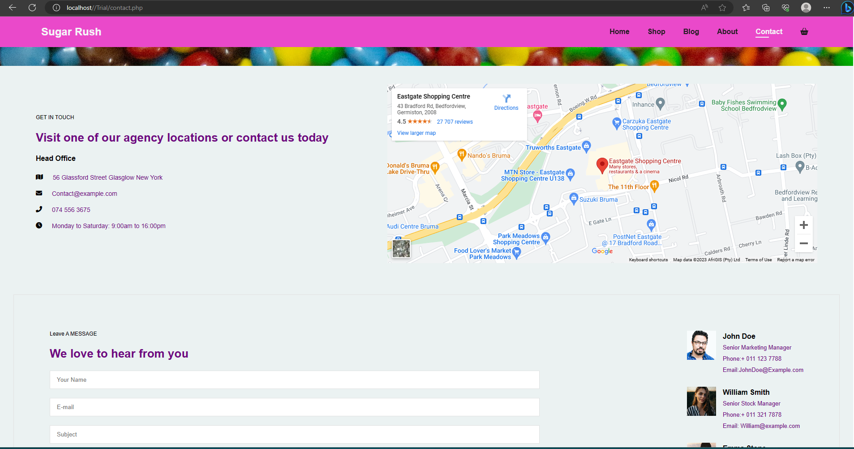

This is the coded About Page, which contains the Business address, Contact details, the opening and closing details. A Functional google Map and below it is Three images of the Senior Managers with their contact information. On the Right side of the page there is a form with a name section, email section and a subject, This allows the user to get into contact with us (Sugar Rush)

This is the Home page being responsive when the page is less than 780px, The items are displayed inline, 2 Next to each other. The item is displayed with the Product Name, Product Description, A review status on the product, a Product Price and a icon to lead to the cart page.

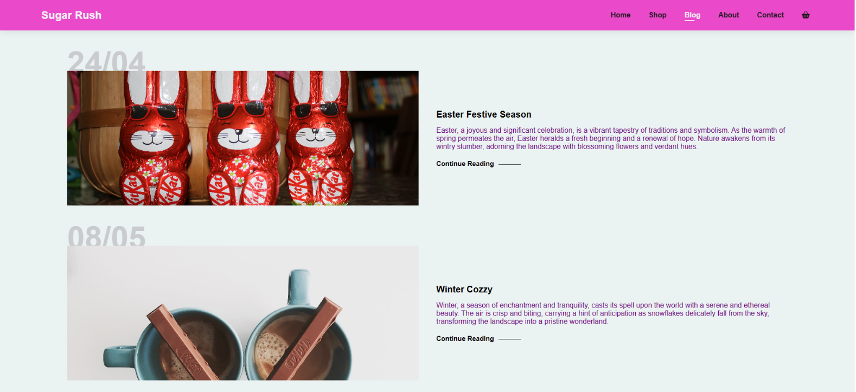

1. **Sample PHP Code**

 <?php

  //connect to the database

  $host = "localhost";

  $username = "root";

  $password = "";

  $dbname = "sugar_rush";

  //creating the connection to the database

  $connection = mysqli_connect($host, $username, $password, $dbname);

  //checking if the connection works

  if (!$connection) {

      die("This Connection has Failed!" . mysqli_connect_error());

  }

  //fetching all products from the database

  $allProducts = $connection->query("SELECT productID,ProductName, ProductDescription, ProductImage, ProductPrice FROM product_table");

  //check if any products exist

  if ($allProducts->num_rows > 0) {

      // Loop through each product

      while ($product = $allProducts->fetch_assoc()) {

          // Generate a unique section ID for each product

          $sectionID = 'product' . $product['productID'];

          // Displaying the product information using PHP

          echo '<section id="' . $sectionID . '" class="section-p1">';

          echo '  <div class="pro-container">';

          echo '    <div class="pro" onclick="window.location.href=\'sproduct.php?ProductID=' . $product['productID'] . '\';">';

          echo '      <img src="' . $product['ProductImage'] . '" alt="" />';

          echo '      <div class="des">';

          echo '        <span>' . $product['ProductName'] . '</span>'; // Display the product name

          echo '        <h5>' . $product['ProductDescription'] . '</h5>';

          echo '        <div class="star">';

          echo '          <i class="fas fa-star"></i>';

          echo '          <i class="fas fa-star"></i>';

          echo '          <i class="fas fa-star"></i>';

          echo '          <i class="fas fa-star"></i>';

          echo '        </div>';

          echo '        <h4>R' . $product['ProductPrice'] . '</h4>';

          echo '      </div>';

          echo '      <a href="cart.php?ProductID=' . $product['productID'] . '"><i class="fa fa-shopping-cart cart"></i></a>';

          echo '    </div>';

          echo '  </div>';

          echo '</section>';

      }

  } else {

      echo "No products found.";

  }

  //closing the database connection

  $connection->close();

  ?>

The following code is used for Connecting to the database(myphpAdmin), it is also used to retrieve the Products From the database and display on the page while formatting from the id class product1.

1. **Sample HTML Code**

    <section id="newsletter" class="section-p1 section-m1">

        <div class="newstext">

            <h4>Sign Up for Newsletters</h4>

            <p>Get E-mail Updates about our latest shop and <span>Special offers.</span></p>

        </div>

        <div class="form">

            <input type="text" placeholder="Your email address">

            <button class="normal">Sign Up</button>

        </div>

    </section>

This code is used for the layout of the Email section in the website, Made up of a section Id called newsletter. Div newstext to control the text. Div called “Form” to control the layout and style on the input section and the button.

1. **Sample JavaScript Code**

/* Navbar responsiveness  */

const bar = document.getElementById('bar');

const close = document.getElementById('close');

const nav = document.getElementById('navbar');

/* When the bar is open and closed */

if(bar){

    bar.addEventListener('click', () => {

        nav.classList.add('active');

})

}

if(close){

    bar.addEventListener('click', () => {

        nav.classList.remove('active');

})

}

This code is used for controlling the menu “hamburger” when the website is displayed in mobile view. This is Applied to the Navbar and has a function that controls it when it is closed or open.

1. **Sample CSS Code**

/* Cart Page */

#cart{

  overflow-x: auto;

}

#cart table{

  width: 100%;

  border-collapse: collapse;

  table-layout: fixed;

  white-space: nowrap;

}

#cart table img{

  width: 70px;

}

#cart table td:nth-child(1){

  width: 100px;

  text-align: center;

}

#cart table td:nth-child(2){

  width: 150px;

  text-align: center;

}

#cart table td:nth-child(3){

  width: 250px;

  text-align: center;

}

#cart table td:nth-child(4),

#cart table td:nth-child(5),

#cart table td:nth-child(6){

  width: 150px;

  text-align: center;

}

#cart table td:nth-child(5) input{

  width: 70px;

  padding: 10px 5px 10px 15px;

}

#cart table thead{

  border: 1px solid rgb(226, 233, 225);

  border-left: none;

  border-right: none;

}

#cart table thead td{

  font-weight: 700;

  text-transform: uppercase;

  font-size: 13px;

  padding: 18px 0;

}

#cart table tbody tr td{

  padding-top: 15px;

}

#cart table tbody td{

  font-size: 13px;

}

#cart-add{

  display: flex;

  flex-wrap: wrap;

  justify-content: space-between;

}

This code is CSS for my Cart page; The cart page has a table in which the Product and its details display. This code controls the style with the content around and inside the table. From the heading to the padding to the color and layout.

1. **Sample MySQL Table Screenshot**

The table represents my products. It is stored in a table called products_table and is stored in a database called sugar_rush. The product table has a ProductID, ProductName, ProductDescription and the ProductImage

1. **Security Features for Sugar Rush**

**Principle of Least Surprise:**

Principle of Least Interest (POLA), also known as the Principle of Least Interest, suggests that software behavior should be user expectations and meetings. By complying with this policy, you will reduce the possibility of user confusion or fraud that could create hidden security risks. Key points for

follow the principle of surprise:

1. creates an intuitive and user-friendly interface that guides the user through the planning process and work.
2. Clearly state the consequences of actions and safety hazards for users. For example, when deleting data, ask for confirmation to prevent accidental deletion.
3. Avoid misleading or deceptive features or UI elements that could trick users into doing things they don't want to do or sharing sensitive information. The
4. Adheres to industry and design standards to ensure your apps follow recommendations, reduce the learning curve for users, and increase security.

By following these practices, you can increase the security of your code and reduce many of the risks associated with validation, error, and user interface design.

**Errors and logging:**

Errors and logging are important for both security and debugging purposes. When problems arise, they need to be secured to prevent sensitive information from being disclosed to attackers.

Best Practices for Error Management and Logging:

Do not send error messages directly to end users as they may reveal sensitive information about your code, application, or underlying system. Instead, give the customer an error message when entering detailed error information.

Use centralized management and security logging tools to capture information about errors, exceptions, and security-related events.

Logs can help identify and investigate security events.

**Authentication and authorization:**

Authentication authenticates the user or entity trying to access your application. It makes users who they claim to be. Authentication methods typically include username/password combinations, biometrics, and tokens.

Permissions determine what actions and resources a user can access when authenticated. It defines the rules and regulations associated with various user roles or groups.

Effective authorization controls ensure that users can only do what they are authorized to do.

Strengthen authentication permissions:

Use strong password policies, such as requiring a combination of upper- and lower-case letters, numbers, and special characters. Encourage users to choose unique and complex passwords.

Use multi-factor authentication (MFA) to add an extra layer of security. This may include methods such as SMS-based verification codes, authentication certificates, or hardware tokens.

Use security management tools to protect users. Use secure session tokens, set appropriate session durations, and force reauthentication for sensitive work.

# Conclusion

Based on the above information, The best website for Sugar Rush would be System Prototype 1 as it accomplishes what the client wants, With the following layout for the website, it will be possible to retrieve data from the database and display it in the website. Functionality will also cater to mobile view and tablet view.

**Link to the Website:**

[Sugar Rush (000webhostapp.com)](https://sugarrushsa.000webhostapp.com/)

# Sign-off

|  |  |  |  |
| --- | --- | --- | --- |
|  |  |  |  |
| ,Martinez Project Client  Date: _11/06/2023________________ |  |  | Saishen Pillay , Project Manager  Date: _11/06/2023_____________ |